GREEN RESPONSE TO DISASTERS

CONTEXT

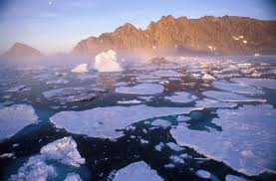
The reality of climate change and its present and potential impact on our societies is now the subject of international consensus. Because of this awareness, sustainable development and ecological transition are key priorities among the challenges we now face.
By causing increasingly serious damage at more frequent intervals, climate change is complicating efforts to reduce poverty in already economically fragile areas.

As a developing region that has been frequently hit by different disasters, the Greater Caribbean is particularly sensitive to the effects of climate change, which has harmful consequences for economic and social development as well as political stability.

In the area of disaster risk reduction and management, the ACS has spearheaded a project, the objective of which is to promote a “green response”, that is, one that is sensitive to the environment during a disaster.
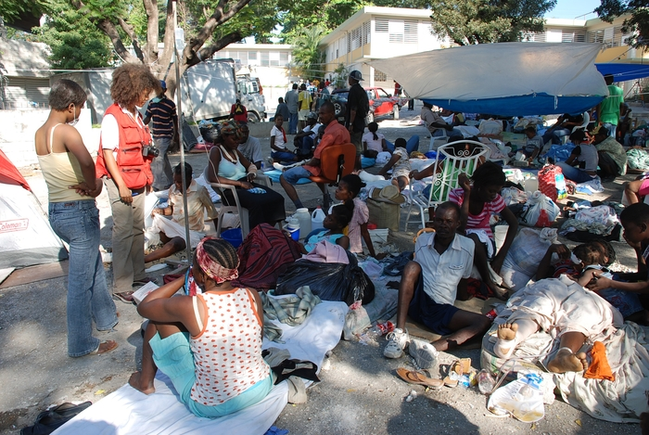
The project entitled “Green response to disasters” arose out of the need to take into account sustainable development, including during crisis situations, because in most cases, mobilisation in such situations is focused on the response to immediate needs without seeking to achieve long-term ecological effectiveness. These responses should respect the values and principles which can help minimise the impact of humans on the environment and thus facilitate sustainable development. The long-term objective is to promote at all levels, the ecological transition that our planet urgently needs.
Credit photo @IFRC
OBJECTIVES

General objective

To provide the governments and peoples of the Caribbean with ecologically effective, environment-friendly tools and processes that they can use in response to disasters.

Specific objectives

- Determine which ecological products and processes are likely to be used in emergencies and during rehabilitation following disasters occurring in the Caribbean (building shelters, lighting, heating, food preparation, supplies of food and water for disaster victims),

- Facilitate the production of the above elements through the use of good practices, case studies, product life-cycle analysis, taking into account their ecological footprint,

- Organise the manufacture and bulk sale of the above items,

- Facilitate the shipment of the pre-stocked products mentioned above to neighbouring Caribbean countries,

- Reproduce this model in Central America, South America and other regions of the world,

PROJECT DESCRIPTION/ACTIVITIES

- Phase 1: feasibility study
- Phase 2: develop/obtain ecological product prototypes from the Caribbean region
- Phase 3: pilot testing of these green product prototypes
- Phase 4: in view of the deployment of the products identified and collected during phases 1 and 2, and the results of phase 3, produce these goods for distribution in Caribbean countries in the case of a disaster

SCHEDULE AND SUMS REQUIRED

Schedule: currently being determined

Financing:
- Phase 1: 140 000 USD
- Phases 2 and 3: to be determined based on the results of phase 1

PROJECT PARTNERS

The International Federation of Red Cross and Red Crescent Societies (IFRC), the Trinidad and Tobago Red Cross and the Office of Disaster Preparedness and Management of Trinidad and Tobago are project partners.

The IFRC is a key player in emergency response, but its objective is also to reconcile disaster management and sustainable development.

The Federation is the largest humanitarian organisation in the world (187 national member Societies, a Secretariat in Geneva and more than 60 delegations across the globe).
Credit photo @IFRC
It is present during relief operations in disasters and crisis situations, and is also involved “pre and post” for long-term development (disaster preparedness, strengthening community resilience and capacity-building in societies, reconstruction and other activities)
The IFRC has broad experience and world-recognised expertise, and is positioned as a service provider to governments in responding to basic needs in the areas of disaster management, health and social issues.

