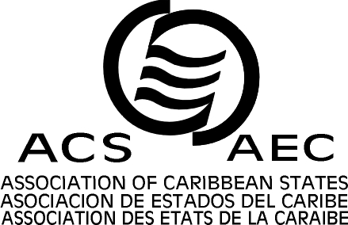


ASSOCIATION OF CARIBBEAN STATES

20th SPECIAL COMMITTEE OF TRANSPORT

Port of Spain, 30th of June and 1st of July 2011

Information and logistics
1. - General information about Trinidad & Tobago
2. - Meeting Details
3. - Opening Ceremony
4. - Registration and Access
5. - Accommodation
6. - Visas

- General information about Trinidad and Tobago

The Republic of Trinidad and Tobago comprises two islands at the southern-most end of the Caribbean archipelago with an area of 5,128 km2, Port of Spain is the capital city, the currency is the Trinidad and Tobago dollar U.S. $ 1 = TT $ 6.28, the country has the largest commercially viable source of natural asphalt in the world, the official language is English, the population of 1,310 million, the Head of State the Honourable Kamla Persad-Bissesar, Prime Minister, and the Honorable Dr. Surujrattan Rambach, is the Minister of Foreign Affairs. June and july marks the beginning of the rainy season and are the wettest months of the year, an average of nineteen (>=1mm of rain) and eight days very wet (>=10 mm of rain), the areas in and around Port of Spain may experience half day / early afternoon thunder rain after a sunny morning.
Maximum temperature 31 degrees Celsius (afternoon)
Minimum temperature of 23 degrees Celsius (just before dawn)
The relative humidity varies between 65 percent and 97
Trinidad & Tobago Meteorological Service website: http://metoffice.gov.tt
Standard time is GMT (UTC) -4
For additional information: http://www.tourism.gov.tt/AboutTrinidadTobago/CountryProfile/tabid/102/Default.aspx
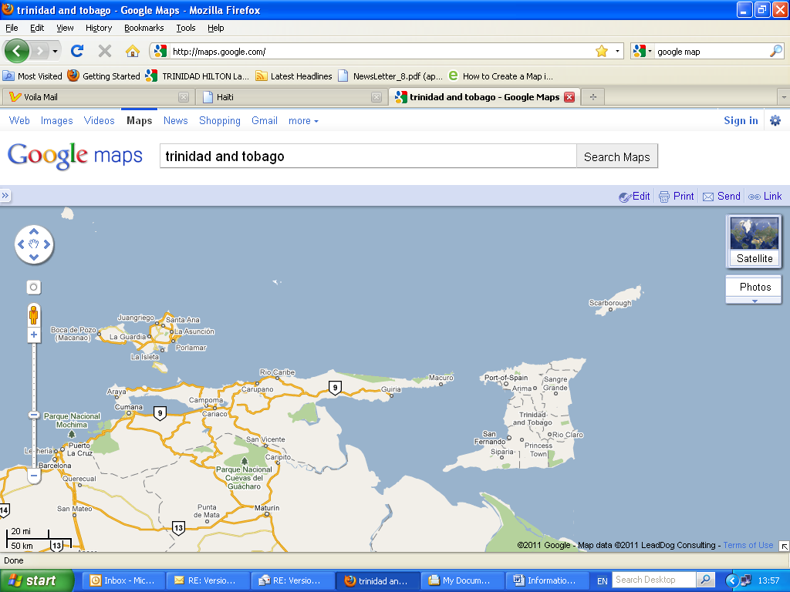

2. - Meeting Details
The 20th Special Committee of Transport of the Association of Caribbean States (ACS) will be held at the headquarters of the Association of Caribbean States, in Port of Spain, Trinidad and Tobago, 30th of June and 1st of July 2011

3. - Opening Ceremony

The Opening Ceremony of the 20th Special Committee of Transport of the Association of Caribbean States will begin on Thursday June 30 at 10:30am with the Opening speech and Report by the President (outgoing, Surinam) of the Special Committee of Transport.

4. - Registration and Access

The registration form attached to this document must be completed by each participant and we respectfully request it to be sent back to the contact email before the meeting. Identification Badges and conference documents will be handed to each delegate prior initiation of the meeting.
Contact persons:
Ms. Sandra Fonseca:sfonseca@acs-aec.org or Ms. Marina Edwards:medwards@acs-aec.org

5. - Accommodation

Find bellow key information regarding the hotel, hotel rates and the contact person to make the reservations. Most hotels will exchange foreign currency or travelers’ cheques, major credit cards are widely accepted at the main hotels and restaurants.

TRINIDAD HILTON  Address: Lady Young Road, Port of Spain  Tél. : (868) 624 3211 / Fax: 624 4485  Email: hiltonpos@wow.net  Point A : the hotel  Point B: the ACS | 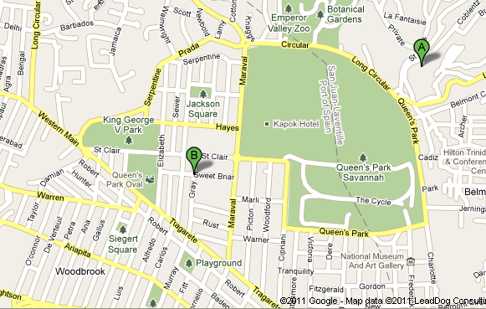
• Rooms:
Standard Single US$189.00  Double US$209.00  Executive Single US$239.00  Double US$259.00  Executive Suite Single US$289.00  Double US$309.00 |  | Rates are subject to 10% service charge 10% room tax 15% VAT on the service charge (total 21.5%) plus utility charge of US$1.95 per room nightly Breakfast is included.

CROWNE PLAZA  Adresse: Wrightson Road, Port of Spain  Tél.: (868) 625 3366 / Fax: (868) 625 4166  Email : crowneplaza@tstt.net.tt  Point A: the hotel  Point B: the ACS | 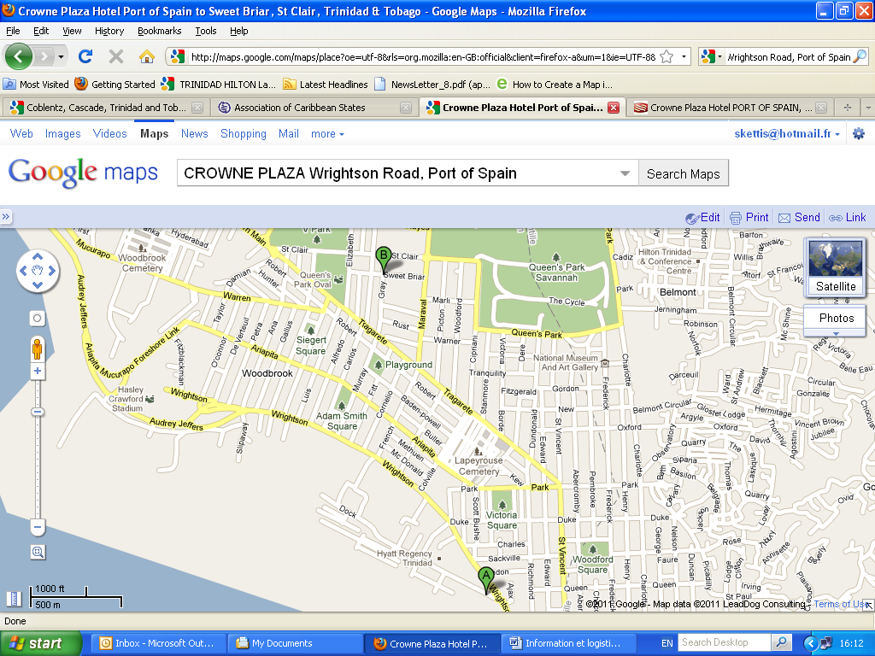
• Rooms:  Standard Single US$248.05  Double US$278.30  Executive Single US$272.75  Double US$302.50 |  | Breakfast and taxes included.

THE CASCADIA HOTEL  Adresse: Ariapita #67 Road, St, Ann’s Port of Spain.  Tél. : (868) 623 4208/9 – 3511/3/5  Fax : (868) 627 8046  Email: http://www.cascadiahotel.com  Point A: the hotel  Point B: the ACS | 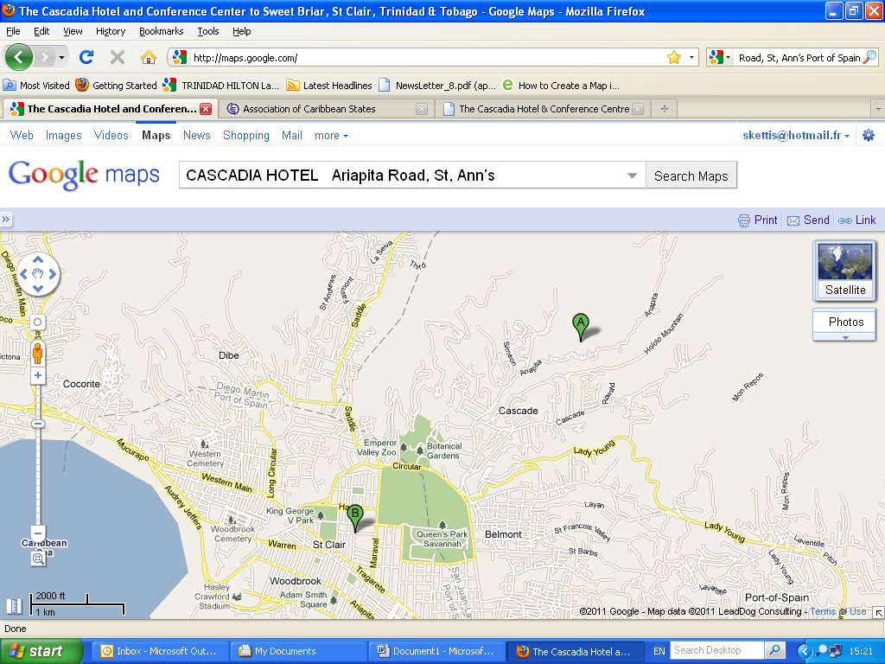
• Rooms:  Single US$180.00  Double US$192.00 |  | Inclusive of breakfast and taxes.

KAPOK HOTEL  Adresse: 16-18 Cotton Hill, Port of Spain  Tél.: (868) 622 5765 / Fax: (868) 622 9677  Email : stay@kapok.co.tt  Point A: the hotel  Point B: the ACS | 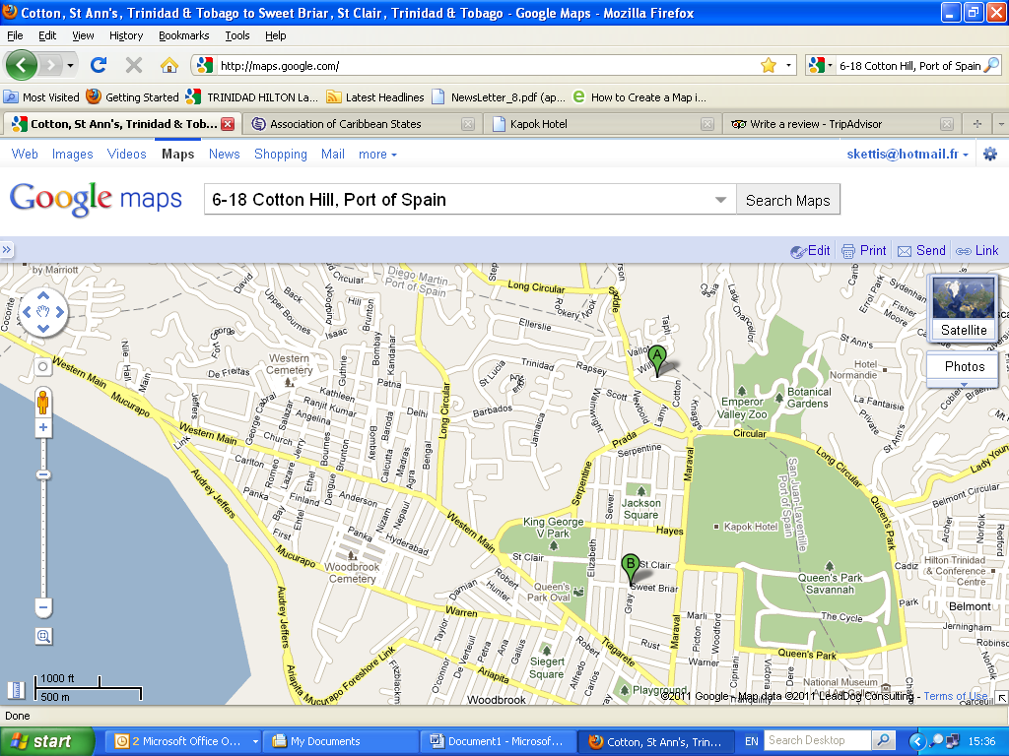
• Rooms:  Standard/Studio Single US$198.05  Double US$217.49  Superior Single US$227.21  Double US$246.65 |  | Inclusive of Breakfast and Taxes.

NORMANDIE HOTEL  Adresse: 10 Nook Avenue, St. Ann’s  Tél. : (868) 624 1181 / Fax: (868) 624 0108  Email : roomsales@normandiett.com  Point A: the hotel  Point B: the ACS | 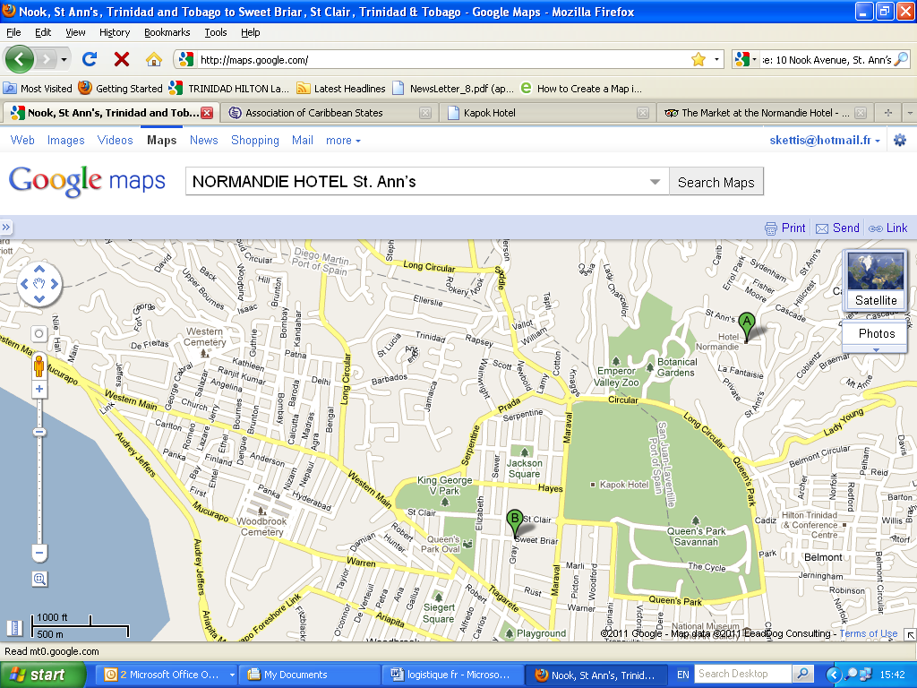
• Rooms:  Loft Single US$132.80  Double US$149.09  Double US$171.23  Standard Single US$133.46  Double US$149.23  Superior Single US$148.86 |  | Executive room Single US$198.40  Double US$231.19  Inclusive of Breakfast and Taxes.

HYATT REGENCY TRINIDAD  Adresse: #1 Wrightson Road, Port-of-Spain,  Tel. : (868) 623 22 22 Fax: (868) 821 6401  Point A: the hotel  Point B: the ACS | 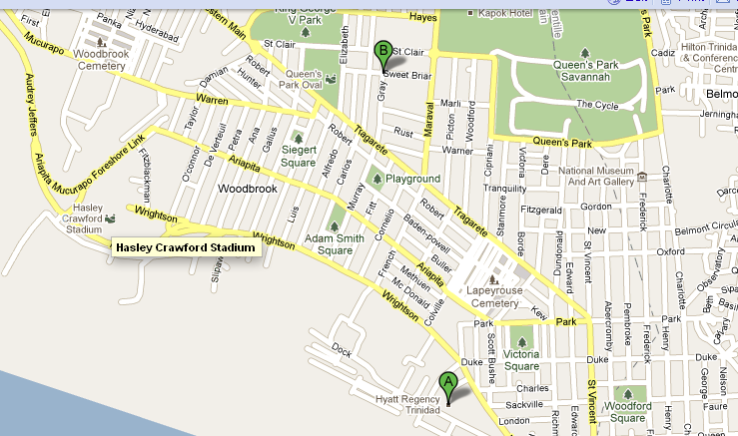
• Rooms:
Contact hotel

6. – Visas

The Ministry of Foreign Affairs of Trinidad and Tobago will assist in procuring visa waivers for delegates provided that information on names, date of birth, passport numbers, date of issue and expiry are forwarded to the Secretariat as soon as possible.
http://www.tourism.gov.tt/AboutTrinidadTobago/TravelTipsandGuidelines/tabid/105/Default.aspx

