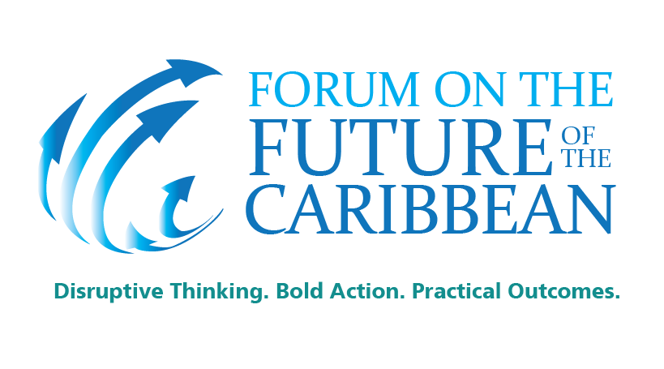
General Information
Event: Forum on the Future of the Caribbean
Event Date: 5 -6-7 May
Location:
5th May, Campus Principal, UWI, St. Augustine, Trinidad
6th May, Hyatt Regency, Port of Spain, Trinidad
7th May, Hyatt Regency, Port of Spain, Trinidad
Admission: by invitation or request
For more information please here-mail: htmic.tt@undp.org
Summary: A unique opportunity to inspire thinkers and leaders, to stimulate new, creative ideas and debate, and to build action around pioneering sustainable development solutions specific to the Caribbean.

From the private sector to the academic world, from the young audiences to the mature minds, everyone is welcome to take part in this leading-edge event.

Article

The University of the West Indies in conjunction with the Ministry of Foreign Affairs and The United Nations in Trinidad and Tobago is hosting a “Forum on The Future of the Caribbean: Disruptive thinking. Bold action. Practical outcomes.”

The Caribbean Forum is a further supported by the Development Bank of Latin America, the Caribbean Development Bank and the Association of Caribbean States

The forum, the first of its kind in the Caribbean, brings together political leaders, academia, private sector leaders, young shapers, civil society and policymakers to engage in a vigorous debate and discussion under the name of: Disruptive Thinking. Bold Action. Practical Outcomes. Caribbean Heads of State and international thought leaders from the US, Nigeria, Malta, the United Kingdom and Chile will be among those present at the event.
In a world of rapidly emerging global processes, Caribbean competitiveness calls for the creation of a new convergence framework and innovative solutions to tackle these demands. Exciting and unexpected solutions must be found to re-ignite growth and address financial difficulties whilst balancing the social and environmental needs of all constituents.
In this context, the Caribbean Future Forum presents an occasion to take inspiration from the financial world and the private sector with a view to building a unique space for discussion around new academic and policy solutions in order to lead to new strategies and commitment to the challenges of Caribbean Small Island Developing States (SIDS).
There are seven main Forum themes:
1. Global Convergence: A Place for the Caribbean
2. Location Strategies for the Caribbean: Convergence of Ideas and of Ideals
3. Building the Resilience of Small States: A Strategic Vision for the Caribbean 2050
4. Multi-dimensional Progress to Tackle Poverty and Inequality
5. Solutions to Sustainable Development Issues in High and Middle Income Caribbean Countries
6. New Diplomacy for Strengthening Financial Capacities and New Global Compact
7. Global Diplomacy in the Caribbean

For more information please e-mail: hmic.tt@undp.org

