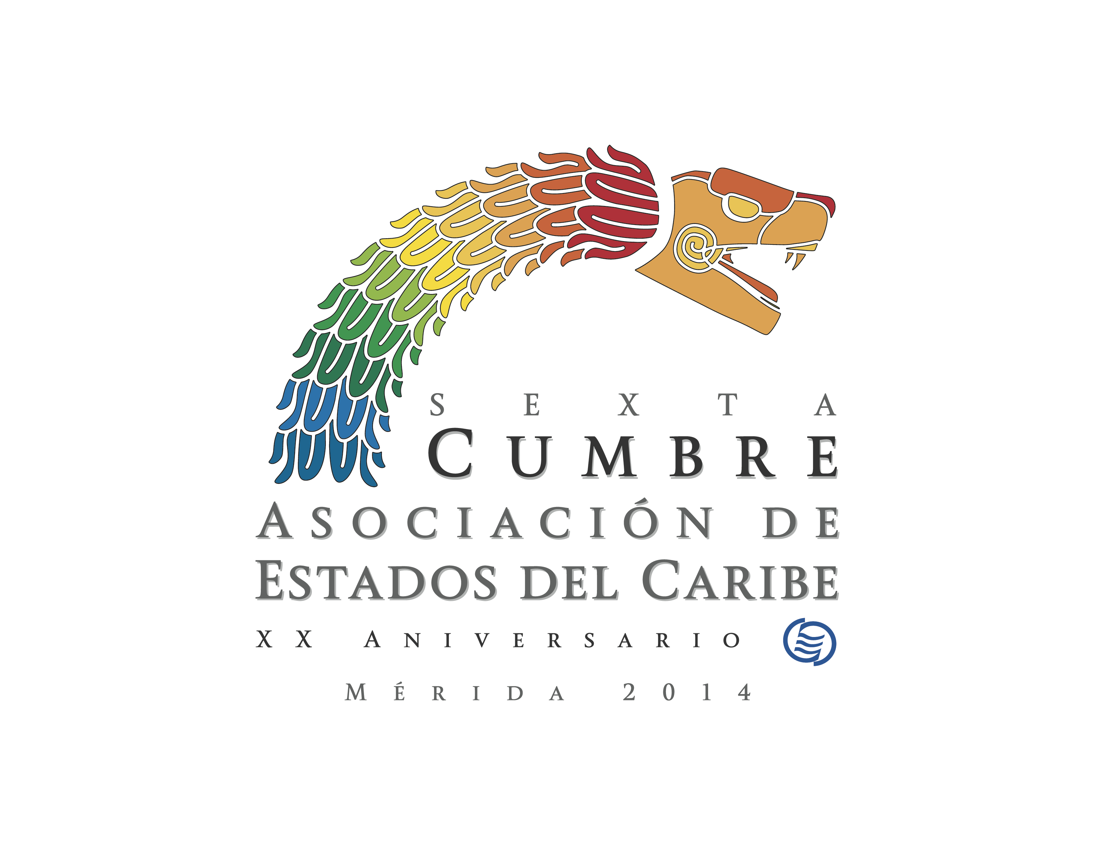

DECLARATION OF MÉRIDA

SIXTH Summit of Heads of State and/OR GOVERNMENT OF THE STATES, COUNTRIES AND TERRITORIES OF THE ASSOCIATION OF CARIBBEAN STATES

Mérida, Yucatán, Mexico
April 30, 2014

DRAFT DECLARATION OF MÉRIDA

In Celebration of the Twentieth Anniversary of the Association of Caribbean States
ACS 20/20: Present and Future

We, the Heads of State and/or Government of the Member States and Territories of the Association of Caribbean States (ACS), meeting in the city of Mérida, Yucatán, Mexico, on April 30, 2014, to celebrate the twentieth anniversary of our Association and to continue moving forward with its strengthening in preparation for future challenges;

1. Underscore the importance of the Greater Caribbean, a region that accounts for almost half of the population of Latin America and the Caribbean and which represents fifty five percent of its total trade, and we reiterate the permanence of the Association of Caribbean States as a special space for dialogue and co-operation in order to make strides in Latin American and Caribbean integration;

2. Are cognisant of the challenges being faced by the Greater Caribbean, particularly the Small Island Developing States, in achieving sustainable development, challenges that have been intensified as a result of an especially complex global context, as
well as the tangible and growing vulnerability to the adverse effects of global warming that are exacerbated by man’s intervention.

3. Reiterate our commitment to integrated regional development, both inclusive and equitable, taking into account the importance of ensuring favourable treatment for small and vulnerable economies.
4. Express our satisfaction with the achievements made during the 20 years since the establishment of our Association, which include the creation of the first Sustainable Tourism Zone in the world, and we underscore our desire to strengthen and consolidate it, in such a manner so as to raise its contribution to the sustainable development and well-being of Member States and Associate Members.

5. Reaffirm our commitment to the Declaration of Pétion Ville which emanated from the 5th Summit of ACS Heads of State and/or Government, convened in Haiti, on April 26, 2013 and to its implementation.

6. Reiterate our commitment to the principles of the United Nations Charter, which are essential for ensuring conditions for efficient cooperation, including the right of all nations to define their own political system in peace, stability and justice.

7. Reiterate our call to the Government of the United States of America to put an end to the economic, commercial and financial embargo imposed against our sister nation Cuba, repeal the Helms-Burton Law and cease its extraterritorial application in the Member States and Associate Members of the Association, in accordance with the 22 pertinent resolutions that have been approved by the United Nations General Assembly.

8. Reaffirm our condemnation of all acts of terrorism in all their forms and manifestations, wherever they are committed and whosoever performs them. We pledge to continue co-operation to effectively prevent and suppress this threat. We strongly reject all unilateral evaluations, lists and certifications.

9. Highlight the priority of our work in the areas of comprehensive disaster risk management to reduce the adverse effects of phenomena, whether natural and/or man-made; transport and improved connectivity in the region; trade development and external economic relations; as well as sustainable tourism, and we pledge to deepen co-operation in such areas.

10. Underscore our intention to co-operate in the areas prioritised according to the mandates of previous Summits in the fields of cultural patrimony, education, science and technology in the Greater Caribbean, in order to achieve and consolidate the inclusion and sustainable development of our peoples.

11. Reiterate our commitment to the protection of the Caribbean Sea and underscore the importance of the mandate of the Caribbean Sea Commission to promote its preservation and sustainable use. We urge the Commission to finalise a work programme containing specific goals and objectives toward the development of the concept of the Caribbean Sea as a “Special Area in the Context of Sustainable Development”, as adopted in resolution A/RES/67/205 of the United Nations General Assembly.

12. Express our satisfaction with the significant advancements recorded by the implementation of the Plan of Action of Pétion Ville, despite the brief period that has elapsed since its adoption, highlighting in particular:

- The entry into force of the Convention Establishing the Sustainable Tourism Zone of the Caribbean on November 6, 2013;

- The entry into force of the Regional Co-operation Agreement in the Area of Natural Disasters on March 31, 2014;

- The convening of the International Workshop on Disaster Risk Management Associated with Natural Phenomena, held on November 25 and 26, 2013 in Mexico City;

- The activation of the Unit for the Management and Follow-up of Co-operation Projects of the ACS Special Fund, which will contribute to the administrative strengthening of the Association, the specific follow-up of the execution of the projects agreed to by Member States and Associate Members and which will help to manage new and increased resources from the international community to cover the costs of projects in the priority areas of the ACS. Thus, the tasks of the Council of National Representatives of the Special Fund will be positively reinforced;

- The implementation of the second phase of the project on strengthening hydro-meteorological operations and services in the Caribbean small island developing states (SHOCS)–Early Warning System;

- The creation of the Working Group on Trade Facilitation to exchange information and promote the integration of the customs systems of the Greater Caribbean;

- The establishment of the Working Group on Business Visas to highlight best practices that could result in a model applicable for the Greater Caribbean region;

- The convening of the Workshop on the Role of the International Tribunal in the settlement of disputes related to the Law of the Sea in the Caribbean region, in Mexico City on June 5 and 6, 2013;

- The establishment of the Sub-commissions of the Caribbean Sea Commission; as well as the hiring of an expert who will draft a proposal

- that will serve as the basis for the discussions of the Caribbean Sea Commission;

kj. The Working Group created by the Caribbean Tourism Organisation (CTO), the Latin American and Caribbean Air Transport Association (ALTA), the International Air Transport Association (IATA) and the ACS to work toward improving air connectivity in the region.

13. Pledge, in light of these advancements and our confidence in the strength of our Association, to continue providing it with tools
that would enable it to respond effectively to the needs of its Member States and Associate Members. Thus, we will:

a. Continue the process to consolidate the Association, to which we give our absolute support;

b. Move forward with the execution of the Plan of Action of Pétion Ville and with the execution of the decisions set forth in this Declaration;

c. Promote a vision that would allow disaster risk to be managed using a comprehensive approach consistent with the policies of the countries of the region that would reduce risk, while transforming us into sustainable countries and territories, as outlined in the Saint Marc Plan of Action and which was made evident in the workshop held on this matter in November, 2013, in Mexico City.

14. Commend the four initiatives presented by Mexico, which are outlined in the framework of the Association´s agenda to strengthen co-operation and we instruct the corresponding competent national entities to work on their execution, in accordance with their respective legal frameworks and the internal policies of each country. We agree to:

a. Exchange experiences for the integration of information systems that would allow us to advance toward the implementation of a platform for a territorial information system in the Greater Caribbean for natural disaster prevention that would contribute to our efforts for comprehensive risk management;

b. Participate in the implementation of a Geospatial Information and Infrastructure System that would respond to the needs of our region and which would allow us to maximise the use of geospatial information for the benefit of our peoples. In this way, the Greater Caribbean region would join in the efforts of the Initiative of the United Nations Committee of Experts on Geospatial Information Management;

c. Work with the major ports in the region according to their classification (hubs, transhipment and small ports), for the purpose of ensuring the development of short distance maritime transport, addressing in particular, logistical and infrastructure issues in small ports, for which a technical project profile needs to be presented;

- Co-operate so that the customs offices of the region could adopt mechanisms to promote Trade Facilitation, through the standardisation of procedures carried out by the authorities controlling the international transit of goods in the region, linking the customs information systems of the Greater Caribbean. We therefore support the expansion of the international transit of goods (TIM) procedure.

15. Applaud the entry into force of the Convention Establishing the Sustainable Tourism Zone of the Caribbean and urge Member States and Associate Members to respect and implement the co-operation framework included in this Convention, whose application will result in benefits for the sustainability of our Caribbean Sea.

16. Call on the ACS Secretariat to convene a meeting during which Member States could reach agreement on a joint strategy and methodology for the purpose of advancing in a coordinated fashion, in measuring the various sustainability indicators established in the framework of our Convention as an evaluation parameter.

17. Reaffirm the desire to strengthen and support the execution of the actions recommended by the Working Group comprising the ACS, IATA, ALTA and CTO, which was created in Cancún in November 2013, to contribute to the development of air connectivity.

18. Recognise the importance of co-operation aimed at identifying and conducting studies in the area of Multimodal Traffic regulation and control in the Greater Caribbean region, in order to contribute to the connectivity of the region and the strengthening of International Trade.

19. We celebrate the 100th anniversary, this coming August 15th, of the Panama Canal, the interoceanic waterway that contributes to the sustainable and economic development of the region and whose expansion project will allow for greater openness and facilitation of maritime trade in the Greater Caribbean region.

20. Instruct the Council of National Representatives of the Special Fund to organise in conjunction with the Secretariat, the “Forum for the exchange of ideas and planning”, which must formulate recommendations to strengthen international co-operation in the ambit of the ACS, as well as identify mechanisms to modernise the management and execution of the projects being handled through the Unit for the Management and Follow-up of Co-operation Projects.

21. Welcome and express our pleasure over the admission of Martinique, Guadeloupe and Sint Maarten to the ACS as Associate Members in their own right, an action which strengthens the process to incorporate all the countries and territories of the Greater Caribbean into our organisation. Toward this end, we underscore the existence of the inter-regional co-operation programme (INTERREG) which finances operational projects for the benefit of the Greater Caribbean.

22. Appeal to all Member States and Associate Members to honour their financial obligations to the Association and to honour their annual contributions on a timely basis.

23. Applaud the process to consolidate the Community of Latin American and Caribbean States (CELAC) and highlight the significant role that the Association of
Caribbean States plays in improving the integration of Latin America and the Caribbean.

24. Equally reaffirm our will to continue promoting the strengthening of co-operation links with other regional organisations toward the more efficient use of resources and the deepening of regional co-operation and integration.

25. Express our solidarity with the People and the Government of the Bolivarian Republic of Venezuela, having regard to the acts of violence taking place in that sister country, which have left behind a regrettable number of victims. We reiterate our unreserved commitment to the preservation of democratic order, to states which are subject to the rule of law, to respect for human rights and fundamental freedoms, and thus support an open and participatory dialogue promoted by the constitutional Government and with political stakeholders and sectors of the society, in the presence of UNASUR and the Vatican.

26. Thank the Secretary General, His Excellency Alfonso Múnera Cavadía, and the entire Secretariat staff, for the fervent dedication with which they have fulfilled, within such a short period of time, the mandates geared toward accomplishing our goals and objectives.

27. Express our heartfelt gratitude to the President of Mexico, His Excellency Enrique Peña Nieto and to the Government and people of Mexico and to the city of Mérida in particular, for their warm welcome and generous hospitality, so evident during the course of this 6th Summit of Heads of State and/or Government of the Association of Caribbean States.

